**DAILY ONLINE ACTIVITIES SUMMARY**

|  |  |  |  |  |  |  |  |  |
| --- | --- | --- | --- | --- | --- | --- | --- | --- |
| **Date:** | **2nd june,2020** | | | | | **Name:** | **Prathusha K A** | |
| **Sem & Sec** | **4th sem &b section** | | | | | **USN:** | **4AL18CS061** | |
| **Online Test Summary** | | | | | | | | |
| **Subject** | | **_** | | | | | | |
| **Max. Marks** | | **_** | | **Score** | | | **_** | |
| **Certification Course Summary** | | | | | | | | |
| **Course** | **Step into Robotic process Automation.** | | | | | | | |
| **Certificate Provider** | | | **guvi path** | | **Duration** | | | **3 hour** |
| **Coding Challenges** | | | | | | | | |
| **Problem Statement: Write a java program to find perfect sum problem.**  **Given an array arr[] of integers and an integer K, the task is to print all subsets of the given array with the given array with the sum equal to the given target K.** | | | | | | | | |
| **Status: done** | | | | | | | | |
| **Uploaded the report in Github** | | | | | **yes** | | | |
| **If yes Repository name** | | | | | **https://github.com/prathu47/lockdown-coding** | | | |
| **Uploaded the report in slack** | | | | | **yes** | | | |

Certification Course Details: (Attach the snapshot and briefly write the report for the same)

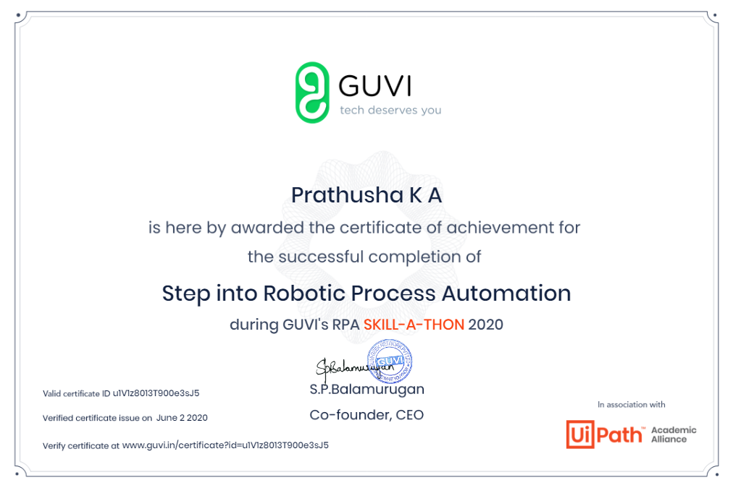

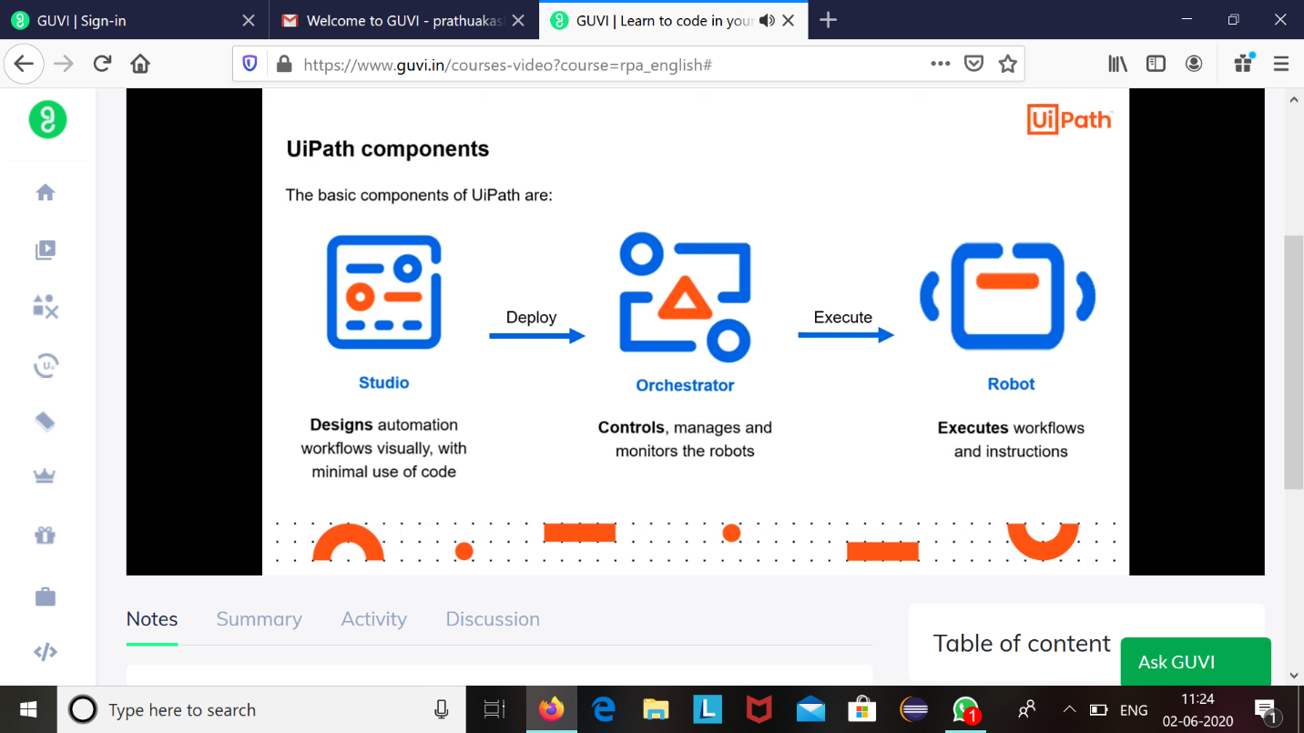

Robotic Process Automation which was taken for 3 hours through guvi path . Robotics are the emerging technology nowadays which replaces the humans works. It helps us to understand basics about Robotics and their Automation.

Coding Challenges Details: (Attach the snapshot and briefly write the report for the same)

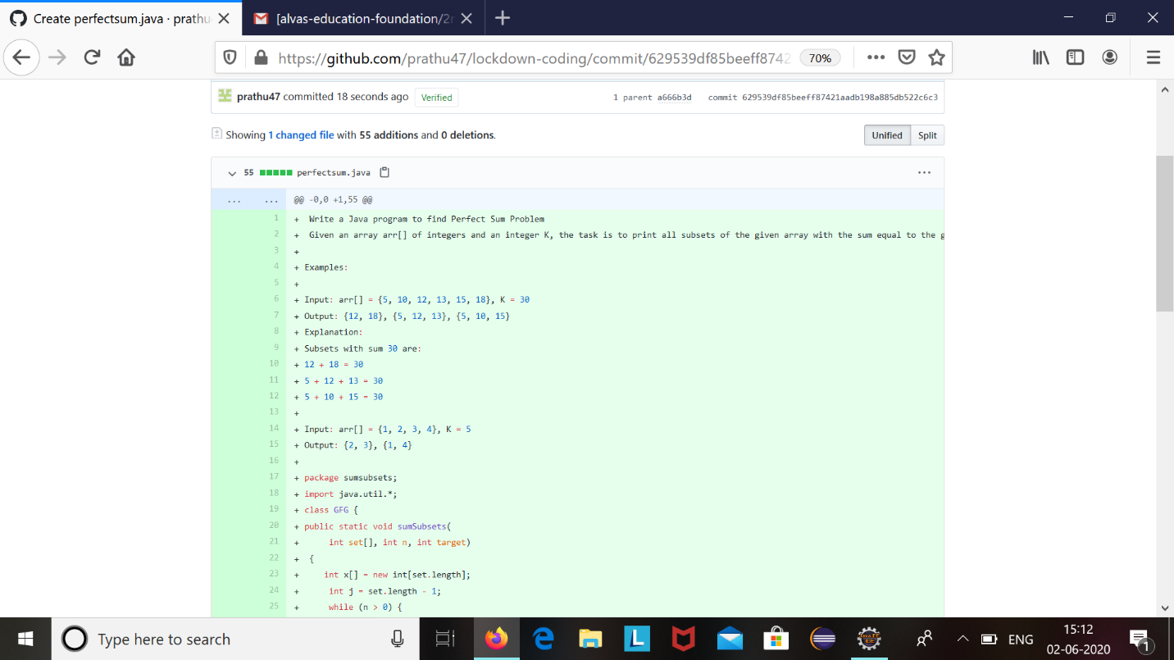

The question we had received today was :

Write a java program to find perfect sum problem

Given an array arr[] of integers and an integer K,the task is to print all subsets of the given array with the sum equal to the given target K.

Code:The above snapshot is the code which I have uploaded in my github repository.